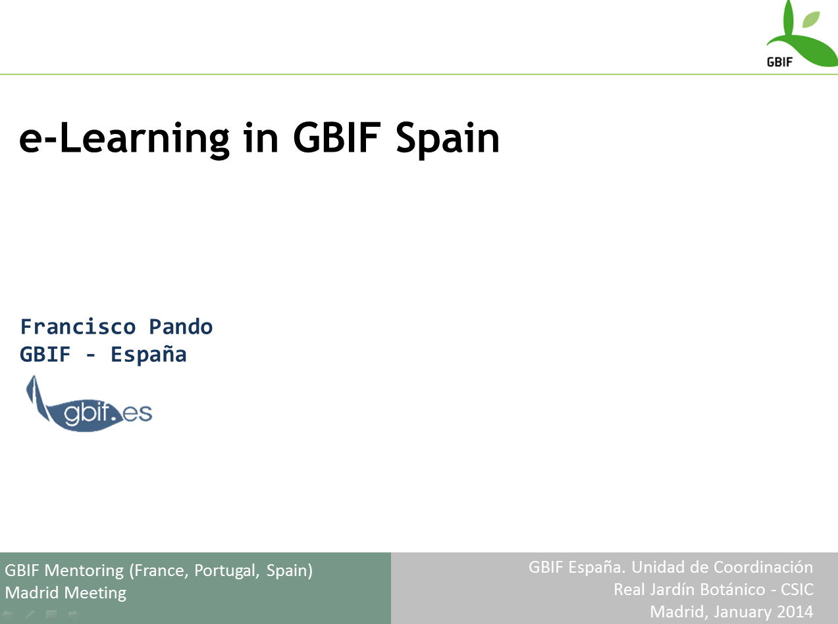

  - The ideas behind
Training is more than teaching and learning contents:
It is a presentation card for GBIF
it builds community (both ways):
To demonstrate that GBIF is for them
To get the pulse of the people that can contribute and use GBIF
We do a lot of training, but we also feel that we should transcend the current
level of activity
  - work with universities to bring biodiversity informatics into the formal studies
  - e-Learning

  - We started in 2009
we had nothing, we knew nothing
we started by exploring the field; learned that there were "platfforms";
- | See Report-elearning-gbifes.pdf

  - We pre-selected 3 platforms:
Moodle
https://moodle.org/
aTutor
http://atutor.ca/
Docebo
http://www.docebo.com/

  - 2010 workshop (Cusco, Peru)
Working within the context of "Ibero-American Platform for Biodiversity Information"; a workshop was organized in 2010 to test e-Learning Platform both in terms of suitability for a GBIF Node, and how will be received by "the community"; We joined forces with the IIAP (Instituto de Investigaciones de la Amazonia Peruana), at tha Time the Peruvian GBIF Node.
Info on the workshop:
  - http://www.recibio.net/recibio/wp-content/uploads/2011/08/Informe_Taller_plataformas_e_eng.pdf
  - http://www.recibio.net/taller-sobre-el-uso-de-plataformas-e-learning/3/
Alberto G. Talaván, from GBIF Secretariat participated in it.

  - What came after
GBIF Secretariat set a GBIF eLearning Task Group
http://www.gbif.org/resources/2592
http://community.gbif.org/pg/groups/1696/gbif-task-group-on-electronic-learning/
GBIF Spain set up an e-Learning Platform based on aTutor (+aContent)
http://www.gbif.es/eLearningGbifes_in.php
GBIF Secretariat decided implement Moodle and set up a Virtual Classroom

  - And where we are now
GBIF Spain
e-Learning tutored courses
2010
Data quality,
2011
Data quality, Data recording,
2012
Data quality, Data recording, Sensitive data
2013
Data quality, Data recording, Georeferencing
2014 (planned)
Data quality, Georeferencing

e-Learning self-taught courses
2013 (ongoing)
on data papers
GBIF Secretariat
http://community.gbif.org/mod/file/download.php?file_guid=2404
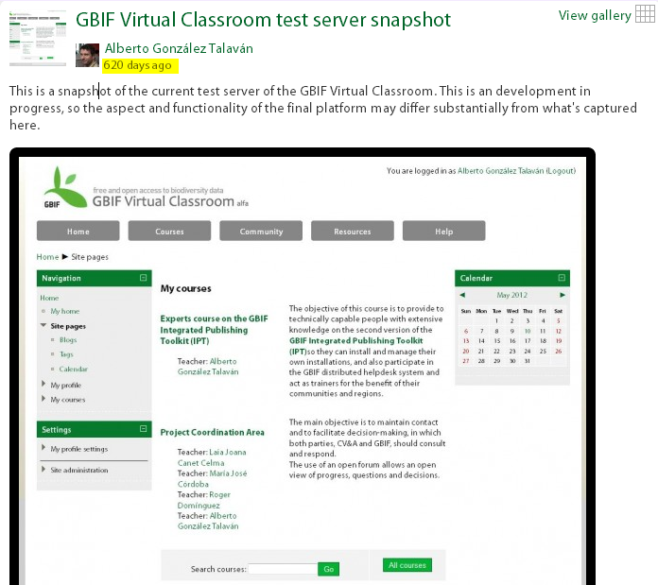
  - Closing remarks, pointers for discussion
    - The base for e-learning is the preparation and experience gained with on-site courses.
    - The sensible number of participants for tutored courses, is only slightly higher than comparable on-site courses
    - Regarding structure and materials; the really new thing of e-learning courses is the evaluation tests
    - As an strategic proposition, we reserve half of the participant places for Latin-American applicants
    - It works!
      - Highly praised
      - highly demanded
    - Challenges
      - Keeping courses current
      - Student's interactions
      - Student's early engagement
    - Other considerations
      - We have capacity to share:
        - to fellow nodes
        - to Secretariat

